

Vendor - SET UP & INSTRUCTIONS

Arrival Times and Set Up
The location of the event is 2nd St Roosevelt to Portland. You can use this location as reference: 1014 N 2nd St, Phx, AZ 85004.

IMPORTANT: Please be on time to set up from 3:00 PM-4:30 PM and be ready to sell by 6:00 PM. The street and event will be live and ready at 6:00 PM. NO VEHICLES ALLOWED AFTER 4:30pm once the street is closed it will not be reopened. Anyone setting up past 6:00 PM or anyone who continues selling after the event ends runs the risk of not receiving an invitation for future participation. ONE VENDOR PER BOOTH.

Entrance Map & Exit Routes
Booth spaces numbered. Please double-check your spacing
area. Also, go over the site map with the entrance/exit routes through 2nd ST and Portland. Following this
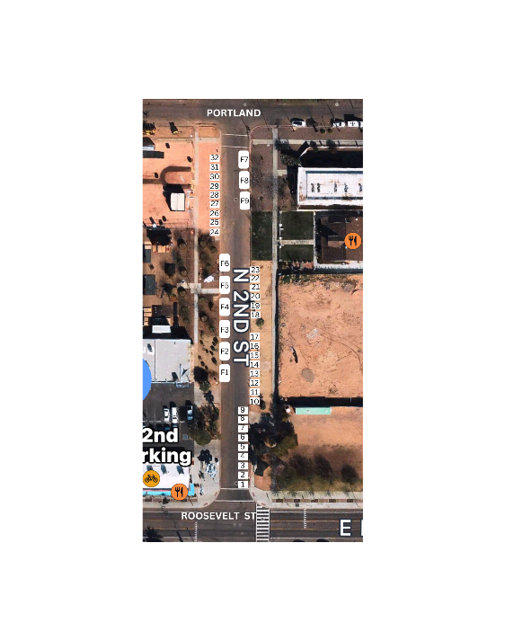
The map is critical for avoiding traffic congestion and expediting the unloading and set up process.

Parking & Towing
We are currently operating under a street closure, and as a result, you will need to quickly drop off your items and park your vehicle off-site. Please note that we do not have a designated parking area, and we strongly recommend paying for parking to avoid the risk of your vehicle being towed.
Mi Cultura AZ is not responsible for any towing fees or parking tickets. If your vehicle is towed, please contact ALL CITY TOWING for further information.

Arriving early will increase your chances of finding free, nearby street parking. Please unload your vehicle promptly and move it immediately to allow space for other vendors to do the same.
Finally, food trucks are not permitted to keep their vehicles on the street. You must detach your vehicle from your food truck and park off-site.

Breakdown
Breakdown time is 9:45 PM sharp. Please be prepared to break down around 9:45 PM and make your final sales. Food trucks and mobile vendors will be located on the edges of the street to help block the street access as a mobile barrier. Therefore, by 10:00 pm food truck vendors should NOT be selling, giving and cooking any food.

Food Truck and Booth Vendor Departure Procedures
To ensure a smooth and efficient departure process, we have established the following guidelines for the end of each First Friday event:
- Food Truck Departure:
  - Due to traffic and logistical considerations, food trucks will be the first to leave the event site. All food trucks must begin their departure at 11:00 PM.
  - No booth vendor vehicles are permitted to enter the event area until all food trucks have completely vacated the premises.
- Booth Vendor Procedures:
  - Booth vendors are required to pack and break down their booths before retrieving their vehicles.
  - Once your booth is fully packed and broken down, you may then retrieve your vehicle, drive in, load your items, and promptly exit the event area.
- Compliance and Penalties:
  - Booth vendors who bring their vehicles into the event area before all food trucks have left will be subject to penalties, which may include fines or dismissal from future First Friday events.
We appreciate your cooperation in following these procedures to ensure a safe and orderly departure for all participants.

Early breakdown is not permitted. If a vendor leaves early without authorization, they will not be invited to participate in the next month. This helps keep a full market for the duration of the evening. This requirement is flexible during slow business or bad weather. Reminder: there are no refunds for bad weather.

Trash Disposal
We're asking all vendors and food trucks BRING YOUR OWN TRASH CAN AND TAKE ALL TRASH WITH YOU PREFERABLY A 32 Gallon Trash Can. Unfortunately, we have limited waste management resources and dumpsters in Downtown. Therefore, all vendors are responsible for providing their own trash cans. Vendors are expected to pick up and dispose of all their trash in the area and take it with you. If any food vendor leaves the area dirty and does not dispose of the trash will receive a $250 fine and may not be invited back. TAKE YOUR TRASH WITH YOU!
Cancellation & Refunds:
If you are unable to attend the event, please notify us as soon as possible at MiCulturaAZ@GMAIL.COM. Vendors will not be reimbursed for any reason, including bad weather or health.

Pricing
- Food Truck $395
- Booth Vendors $75
- Booth Food Vendors $95
- Business Promotions $100

Payments
Effective March 3, 2024, participation in First Friday events necessitates payment exclusively through invoicing. Cash payments will no longer be accepted. Failure to submit payment by due date will result in removal from the roster, with reinstatement contingent upon availability on the waiting list.

Lastly, make sure you're set up for success. Here's your checklist to glance through before you head over:

Vendor Preparation Checklist

- 32 Gallon Trash Can & Bags (REQUIRED) You are responsible for the trash in your vending area and must be taken with you or you will be fined & not invited again.
- Lighting
- Long industrial extension cord
- Electric Generators (REQUIRED) for your lighting
- PREFERRED Led Light Bulbs
- REQUIRED - Energy Efficient (CFL) Light Bulbs- Max of 4 per space *No halogen, incandescent, non-LED twinkle lights, or heaters allowed
- Signage (banner and/or table top item describing your business and products)

Vendor Participation Policy

Dear Valued Vendor,

We want to ensure that all our vendors clearly understand our participation policy. While we appreciate your involvement in our events, please be aware that no vendor is guaranteed a recurring spot. Participation in one event does not automatically secure your space for a future event.

Due to the high demand and a continuously growing waitlist, we aim to offer opportunities to a diverse range of vendors. This approach allows us to showcase a variety of businesses and helps us collectively represent and celebrate our culture.

We kindly ask for your patience as we work to respond to all inquiries and improve our organizational processes. Your cooperation and understanding are greatly appreciated as we strive to create a vibrant and inclusive environment for everyone involved.
Thank you for your continued support.

Sincerely,

Mi Cultura AZ

Mi Cultura AZ Vendor Emergency Exit Safety Reminder

As a valued vendor at Mi Cultura AZ, it's crucial to ensure the safety of all participants by following these guidelines:

- Emergency Access: We are in an emergency entrance and exit zone. Therefore, a minimum clearance of 20 feet must be always maintained—before, during, and after the event for Police Department, Fire Department.
- Emergency Protocol: In the event of an emergency, please assist in clearing the crowd in the safest and most efficient manner possible. No vehicles are permitted on-site during an emergency under any circumstances. Food trucks must remain parked, and vendor booths should evacuate immediately by heading northbound to 2nd Street & Portland.
- Traffic & Setup: Due to our location, it's essential to manage traffic and setup with care. We ask for your cooperation in being proactive and understanding the importance of these measures.
- Vehicle Entry Post-Emergency: If the situation allows vehicles to return, vendors will be allowed to bring their vehicles in North to South, starting with those closest to Portland.
- Non-Compliance: Failure to adhere to these rules will result in immediate eviction and disqualification from future events.
Your cooperation is essential in ensuring the safety of all. Thank you for your attention to these important guidelines.

